Connect  (What’s your first thought?)  Write Answers in Scientific Notation | Compare  (Discuss with your partner how they solved this problem?) | Correct/Collaborate  (Collect information from video. Be discuss with partner about learning)
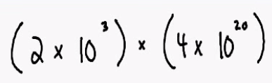 |  | What is the product of powers property?
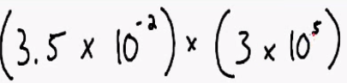 |  | How does the product of powers property help you with this problem?
Objective | *Multiply and Divide Numbers in Scientific Notation | Common Core State Standards 8.EE.4  http://safeshare.tv/w/NhDSIiDubz

