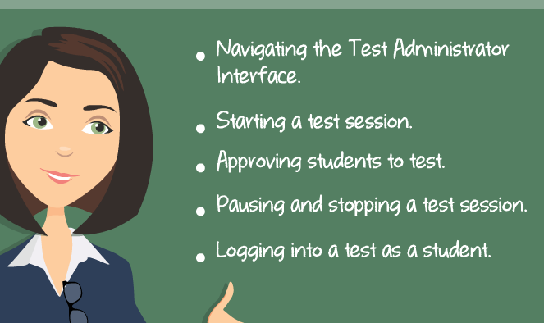
Slide 2
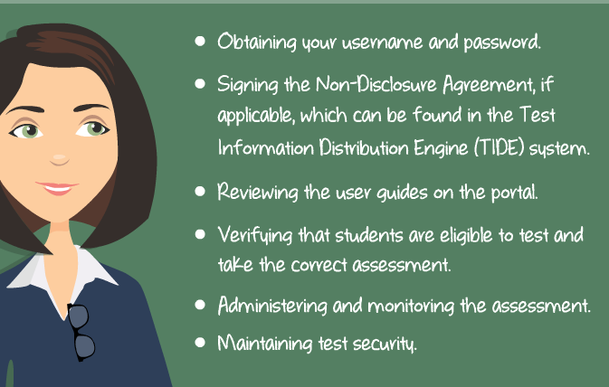
Slide 4
*AzMERIT Browser is already installed on Chromebooks SO students will NOT download the secure browser before testing

*Test Tickets Provided

Slide 3
*Copy Provided of Non-Disclosure Agreement ----please sign and return
Questions: 1) Refer to your copy of User Guide 2) Angela Eaton 623 824 6896
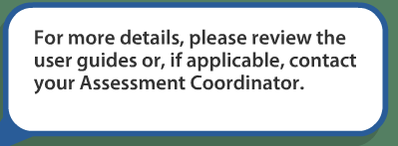
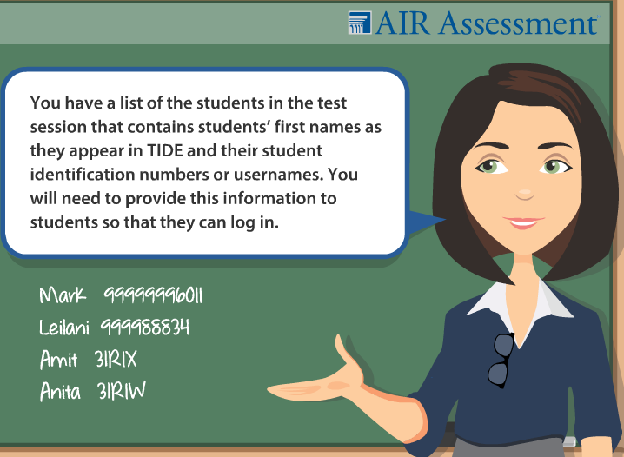

Accessing the Online System (Slides 5-6)
- Go to azmeritportal.org & select Educators & Test Administrators
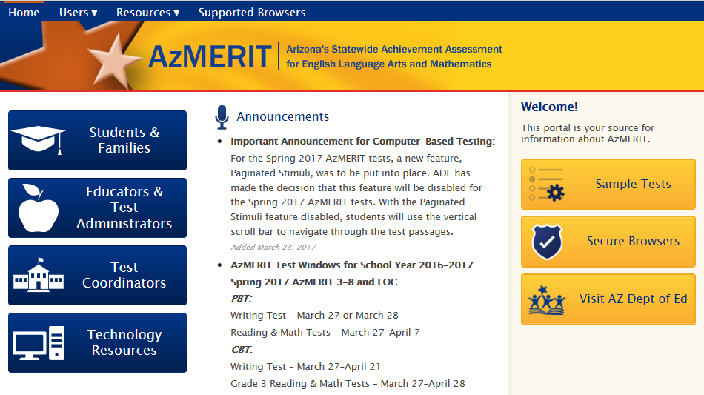
- Select Administer Spring 2019 AzMERIT Tests & Enter Login
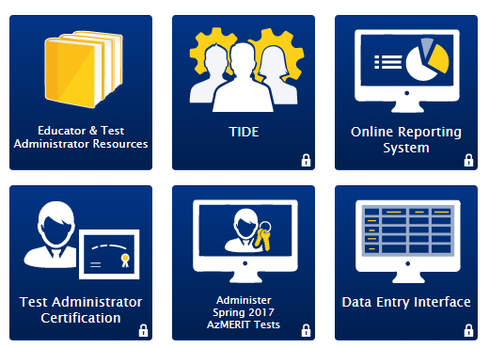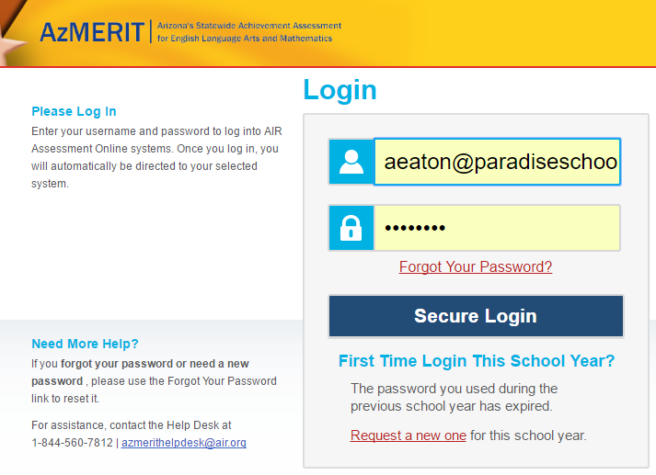
***If pop-up blocker is turned on then disable by…
-Click pop-up blocker symbol and Always allow pop-ups and refresh button
OR Click Always Allow AND Refresh button

Starting an Online System (Slides 7-9)

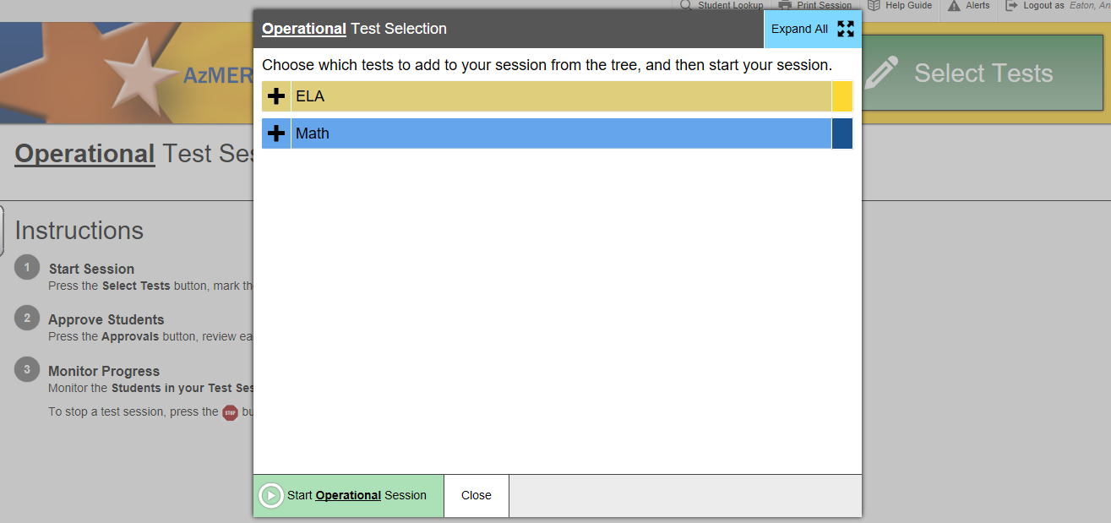
Operational- means you are in a LIVE test
Select Help Guide at top for user guide information
- Select the Test you would like to Administer in ELA or Math in Grades 3-8
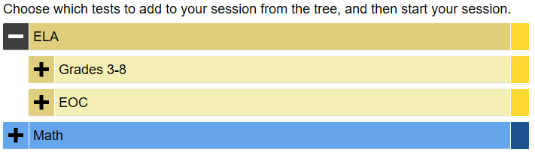
Writing will ALWAYS be administered first
Refer to testing schedule for the specific dates for ELA and Math
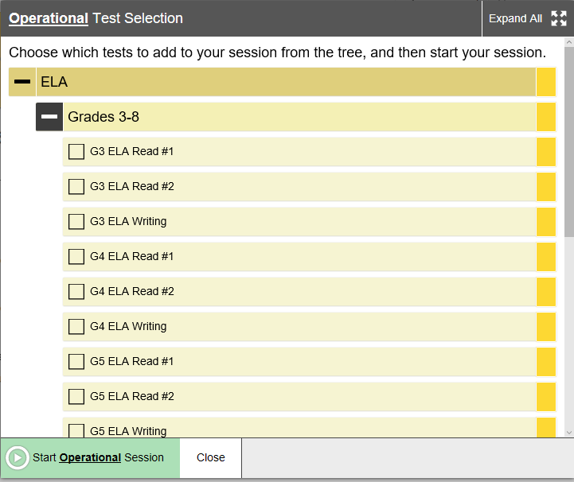
If you close window then you can access test by selecting Select Tests at top of screen
- Begin testing session by clicking Start Operational Session once you have selected test
- Write Session ID on board BEFORE students begin testing (They need Session ID to login)
Student Look Up to Find Information (Slides 10-15)
- Students will need first name (as appears on TIDE), student identification number, AND Session ID to login
Testing Tickets were provided for your class that include first name and student identification number
After completing Accessing Online System you will have Session ID
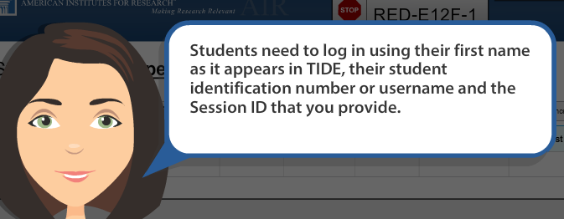
**If you students LOST their testing ticket then you can look up information**
- Click on Student Lookup to find students first name (appears in TIDE)
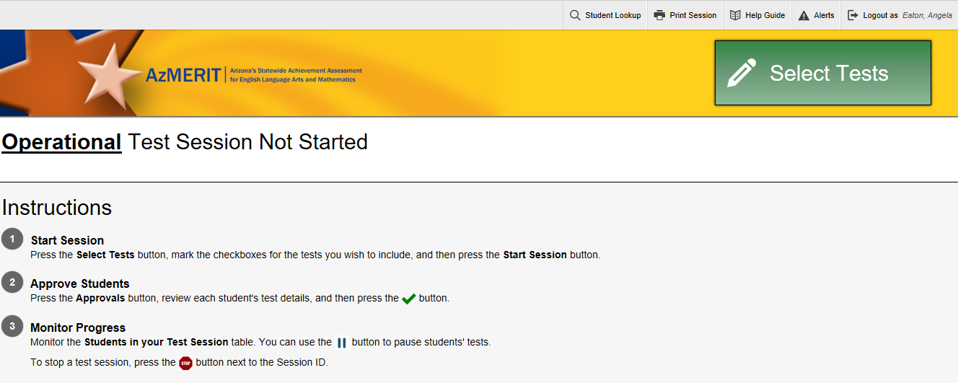
Quick Search
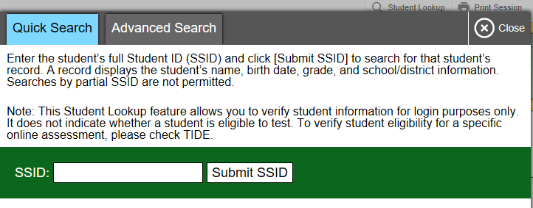
The student Look Up feature can be used to verify a student’s log in information
Advanced Search (show student’s ID number)
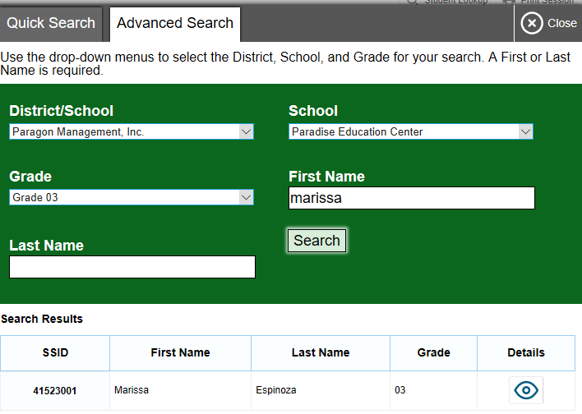
.
Click the eye symbol to find students SSID number, grade, and date of birth
Student Login (Slides 17-19)
- Students will login with FIRST NAME only, Student ID, and Session ID
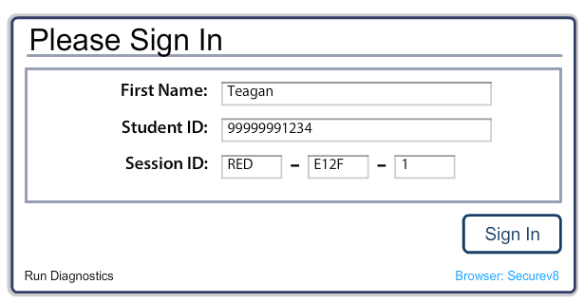
Just FIRST Name
- Confirm Demographic Information
If correct, then students will select YES button
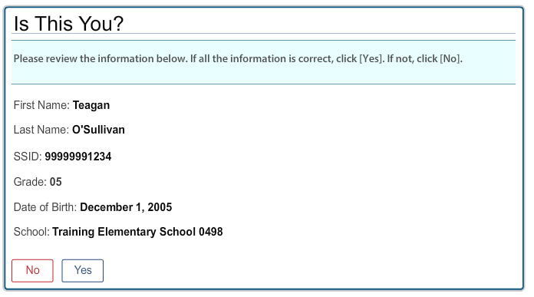
- Eligible tests are listed and students will click test
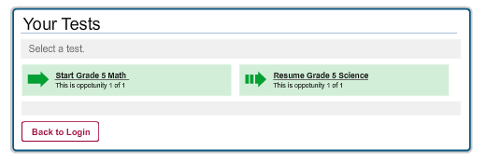
- Students will see a screen to wait for Test Administrator Approval
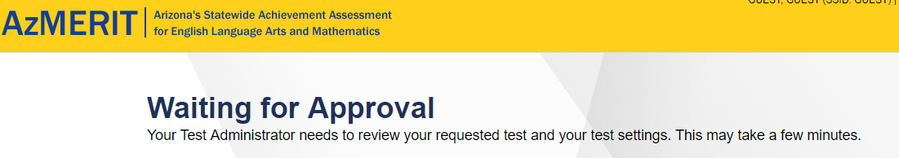

*All tests must be approved by test administrator before they may begin
Approving and Reviewing Students (Slide 20-27)
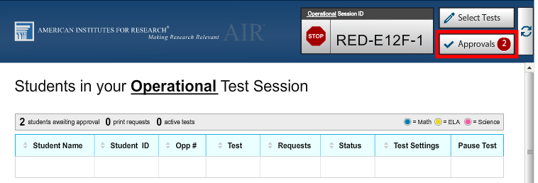
Helpful Hint:
Select Refresh Button if approvals not immediate
- Select Approvals button to approve students for testing (found at top right of screen)
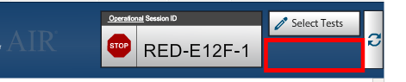
Blank space means NO students need approval
- Approvals and Student Test Setting Screen help you identify students WITH and WITHOUT accommodations (Standard vs Custom)
-Note- Accommodations have already been entered into TIDE but please verify that your students have CUSTOM details listed
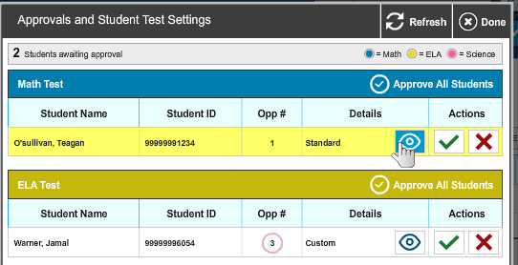
A test administrator can see student’s test progress directly on TA interface
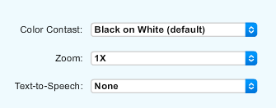
- Select the Approves All Students button
- Once approved you will see a list of students in testing session
Status Column shows the questions students are on
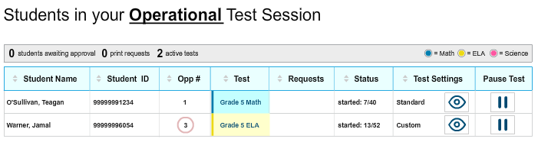
Student View (Slide 34-39)
- After students have been approved, it will ask if information is correct. If yes, then students will select Yes, Start My Test
*If incorrect, then select NO and notify Test Administrator
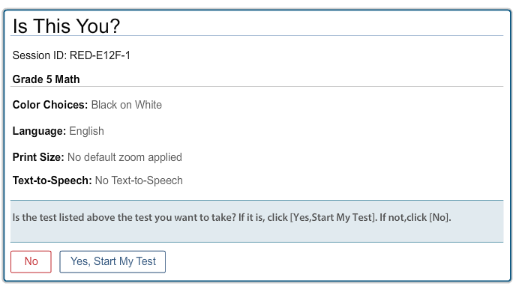
[Type a quote from the document or the summary of an interesting point. You can position the text box anywhere in the document. Use the Drawing Tools tab to change the formatting of the pull quote text box.]
- Some test prompt SOUND check. Select speaker icon
If audio is clear, then student will select YES
If audio is NOT clear, then student will select NO
-after student selects NO, then ask them to log out of secure browser
-TA (test administrator) will change settings on headphones
-log back into AzMERIT secure browser
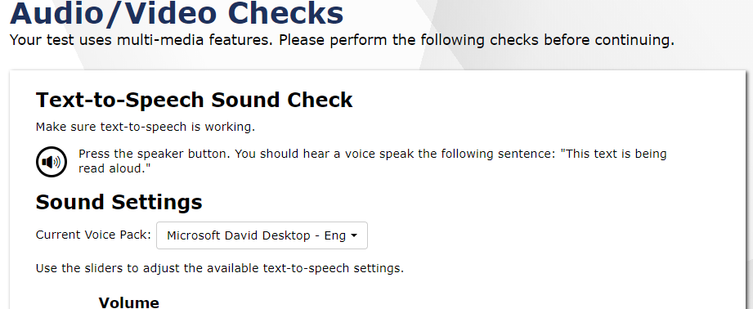
- Test Instructions & Help box provide online tools & keyboard shortcuts)

- Students will select Begin Test
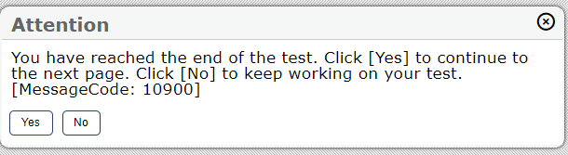
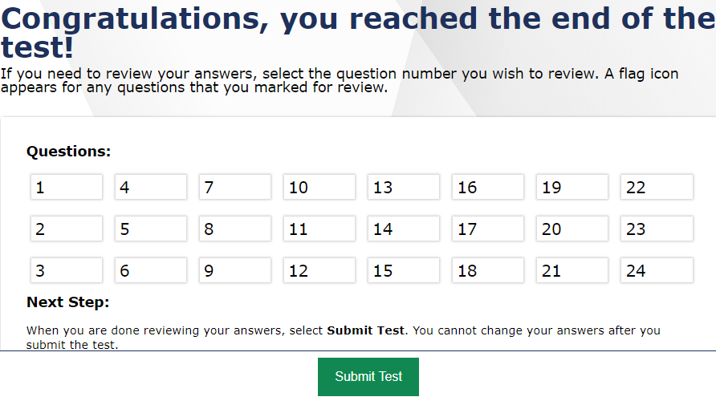
- Submit Test & Log Out
*Students prompted
to review answers
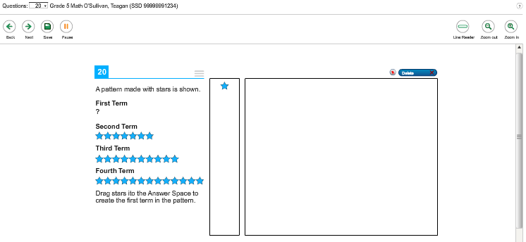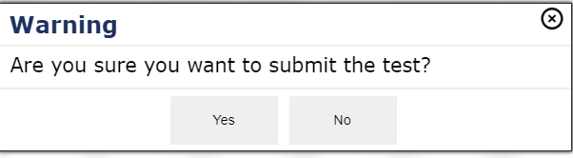
Pause Test (Slide 40)
- Pause a student’s test at any time by clicking Pause Test button
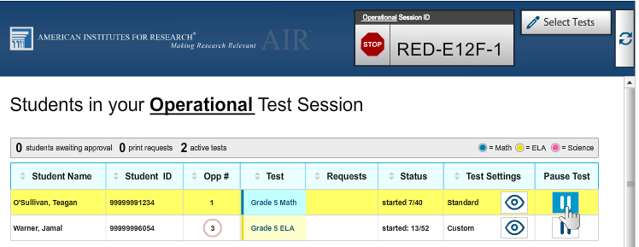
- If a student test is paused, then the student will have to log back in within a certain amount of time
Margaret Bowerman, “There should not be a significant pause for students. Typically a student will pause the test to use the restroom or move to another room to continue testing. This shouldn’t take more than 10-15 minutes. If a student needs to go to the nurse, he or she can pause the test for up to an hour or so if needed. The test administrator will need to keep the session open until the student submits the test.” 2019
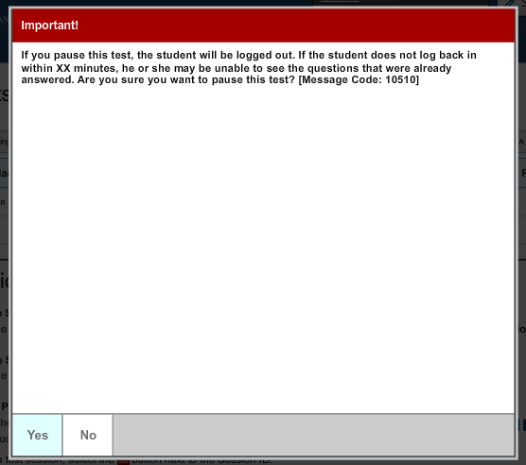
- Test Administrator will have to go through Approving and Reviewing Students process again
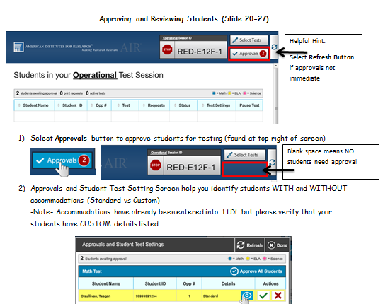
- Student will have to log back in and BEGIN on the next unanswered question
Stop Test (Slide 41-42)
- To End Session click the RED STOP SIGN
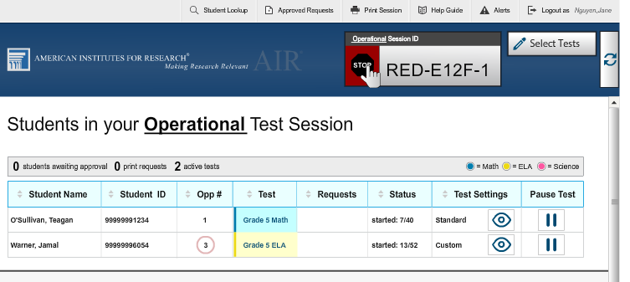
- Confirm that you would like to STOP session
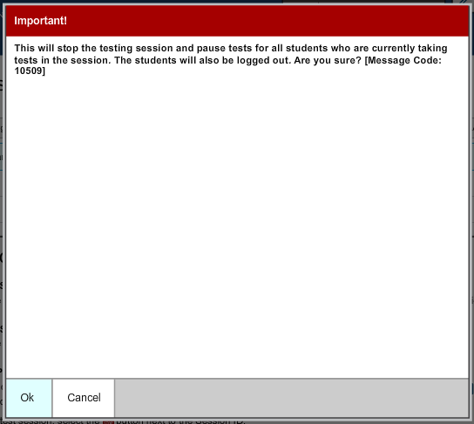
- We will not be taking test over MULTIPLE days so you do not need to PRINT SCREEN
Each testing day will have a different session ID
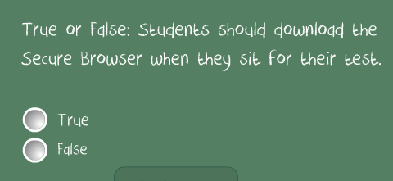
Hint: Slide 4

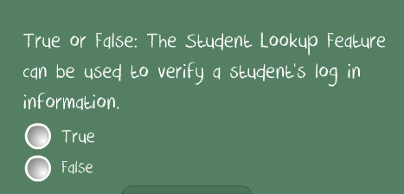
Hint: Slides 11-16

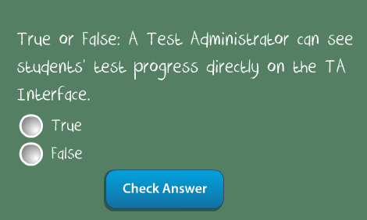
Hint: Slides 20-27

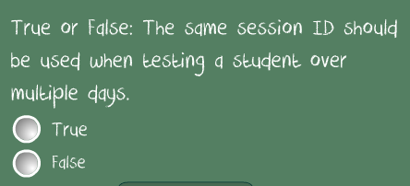
Hint: Slides 41-42

