Swihart’s Class,

Look within yourself to find greatness! You will do amazing things today!

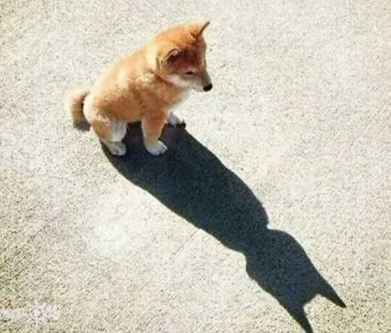

I’m Batman