- Start Up Chromebook
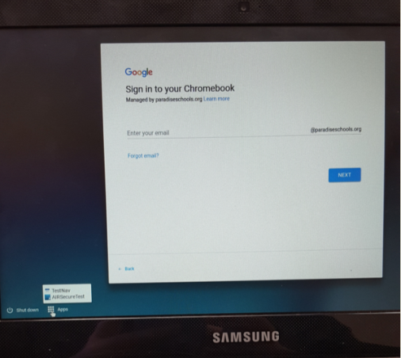
- Select APP at bottom of Screen (Do NOT log into the Chromebook)

- Select AIRSecureTest at bottom of Screen (Be sure to select AIR Secure Test)

- Students are ready to
Login Log Out (at end of testing)
