- Go to azmeritportal.org
- Click Educators & Test Administrators
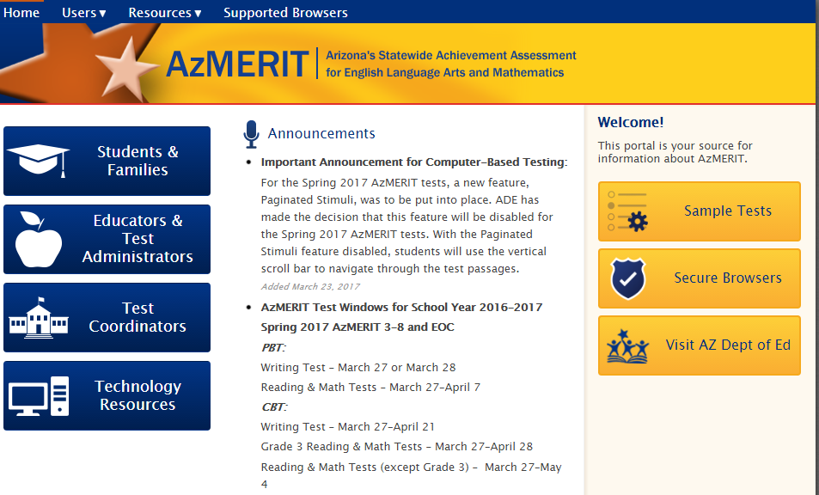
- Select Test Administrator Certification
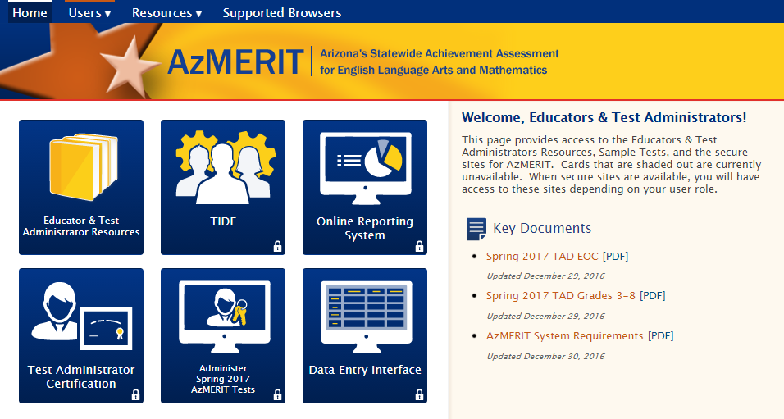
- Login into AzMERIT Portal (email for username and select password)
New Security Procedure
2019
If you have cleared your browser cache, the Enter Code page appears and an email is sent containing a code.
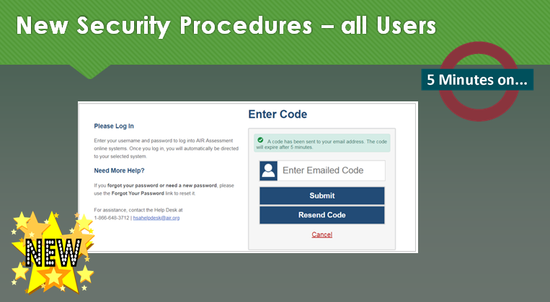
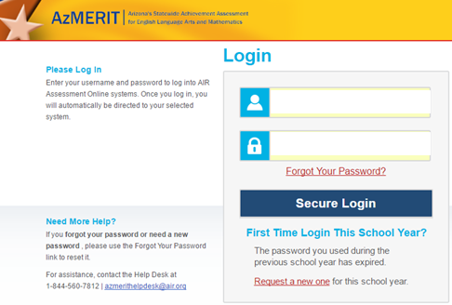
If you forgot password, then please click
Request a New One and follow directions within email

- Begin AIR Assessment Training
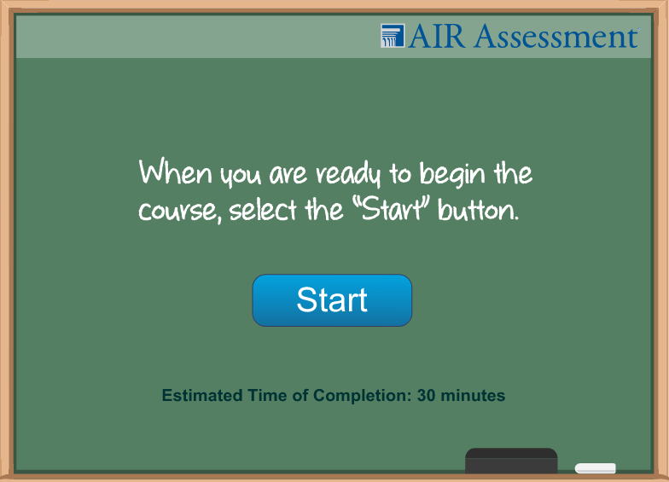 (The course is timed and will not allow you to move ahead 33 minutes)

