- Log into azmeritportal.org
- Click on Educators & Test Administrators
- Select Test Administrator Certification
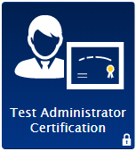
- Enter username and password

*2019 New Security Procedure
There are new security procedures for all users this year. If you have not logged in using this browser, or if you have cleared your browser cache, the Enter Code page appears, and an email is sent to your address. This applies every time you access TIDE with a new browser. The email contains a code, which you must use within five minutes of the email being sent. You must enter the Emailed Code and click submit. If the code has expired, click the Resend Code to request a new code.
