Before AzMERIT Testing
*Launch the AzMERIT Secure Browser on each student Chromebook
*Write the Session ID clearly on the board
*Post “Testing Do Not Disturb Sign”
*Distribute testing tickets
*Distribute Scratch Paper (only Math and Writing)

Test Administrator Approve Students
*Check for accommodations
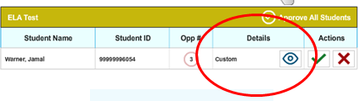
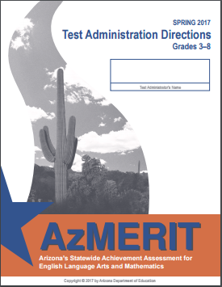
Read Directions Throughout AzMERIT Computer Based Test

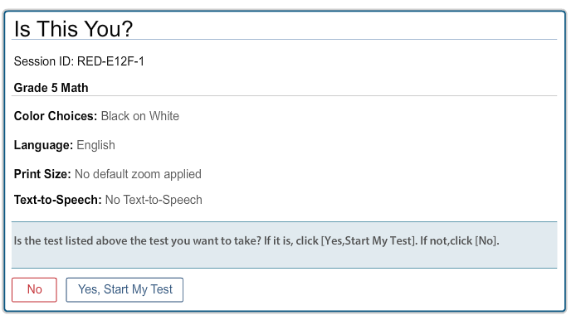
Students Verify and Begin Test AFTER Approvals
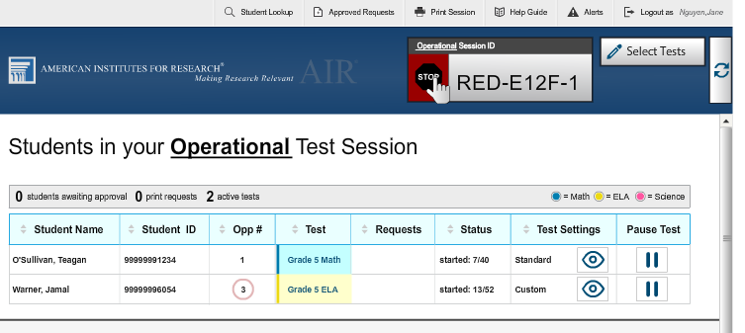
End Testing Session
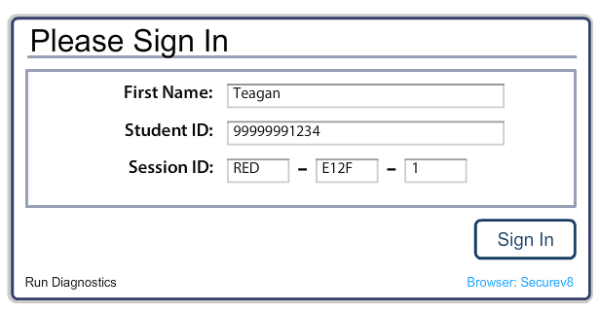Students Log into Secure Browser
Get Session ID
How to Get the Session ID
Step 1: Sign into AzMERIT Portal
- Go to azmeritportal.org & select Educators & Test Administrators
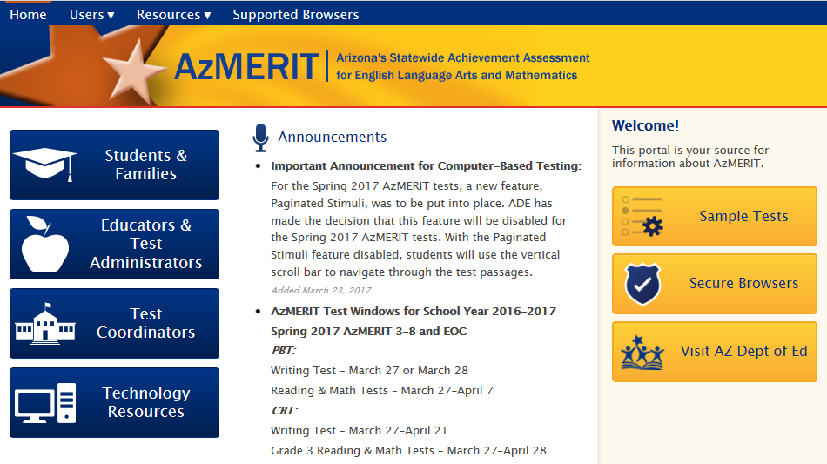
- Select Administer Spring 2017 AzMERIT Tests & Enter Login
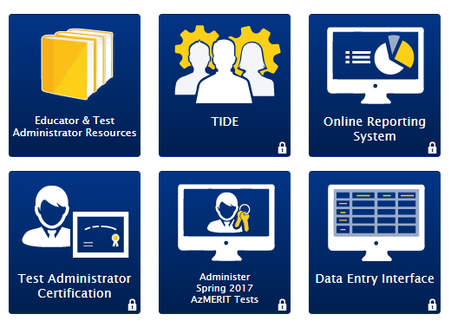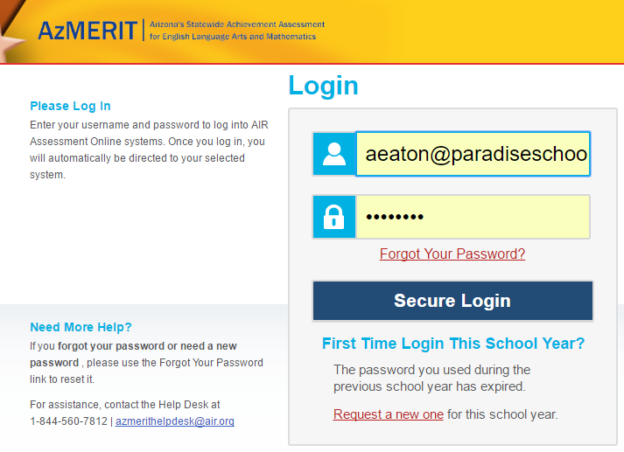
***If pop-up blocker is turned on then disable by…
-Click pop-up blocker symbol and Always allow pop-ups and refresh button
OR Click Always Allow AND Refresh button

How to Get the Session ID
Step 2: Select Test (Be sure you are looking at which day to give test)

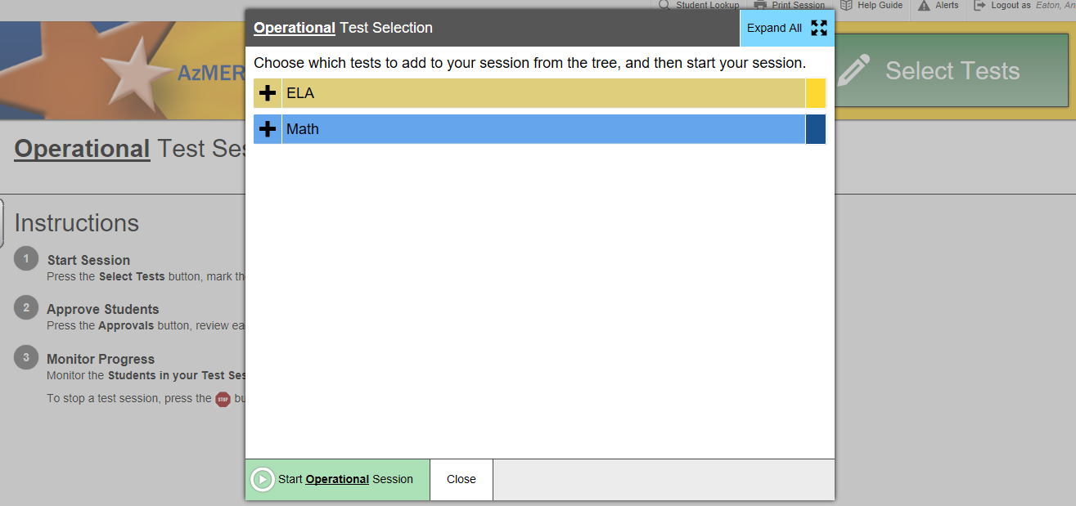
Operational- means you are in a LIVE test
Select Help Guide at top for user guide information
- Select the Test you would like to Administer in ELA or Math in Grades 3-8
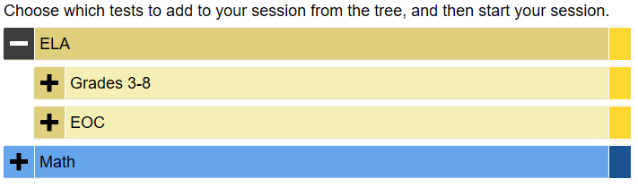
Writing will ALWAYS be administered first

Refer to testing schedule for the specific dates for ELA and Math
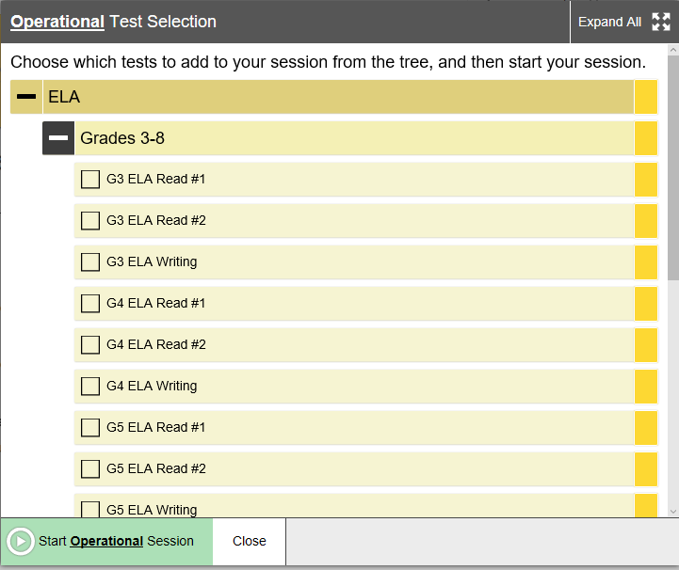
If you close window then you can access test by selecting Select Tests at top of screen
- Begin testing session by clicking Start Operational Session once you have selected test
- Write Session ID on board BEFORE students begin testing (They need Session ID to login)
How to look up Student Information to FIND Testing Ticket Information
- Students will need first name (as appears on TIDE), student identification number, AND Session ID to login
Testing Tickets were provided for your class that include first name and student identification number
After completing Accessing Online System you will have Session ID
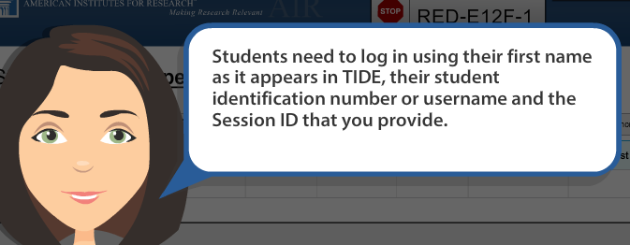
**If you students LOST their testing ticket then you can look up information**
- Click on Student Lookup to find students first name (appears in TIDE)
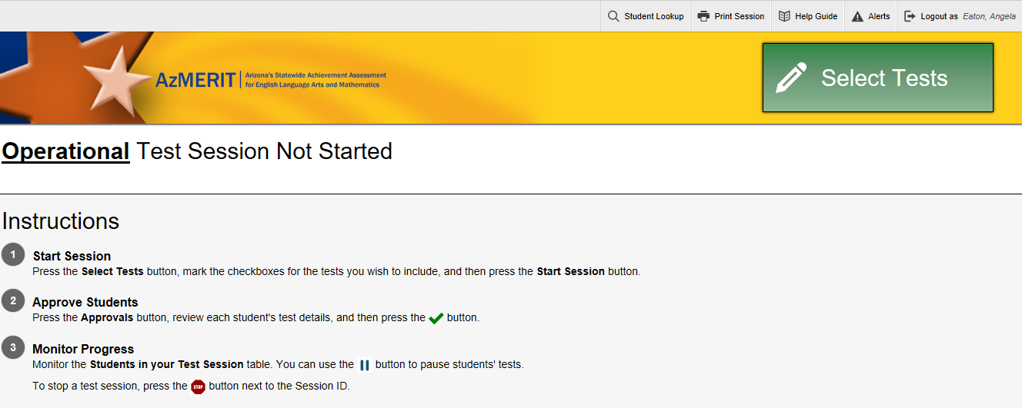
Quick Search
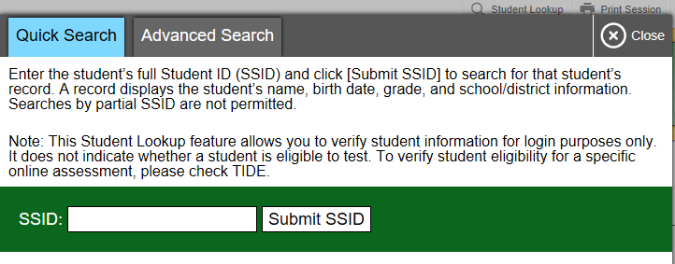
Advanced Search (show student’s ID number)
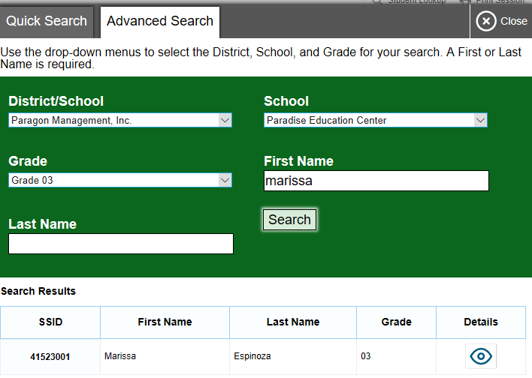
Click the eye symbol to find students SSID number in addition to first and last name

Students Login INTO AzMERIT Secure Browser
- Students will login with FIRST NAME only, Student ID, and Session ID
- Confirm Demographic Information
If correct, then students will select YES button
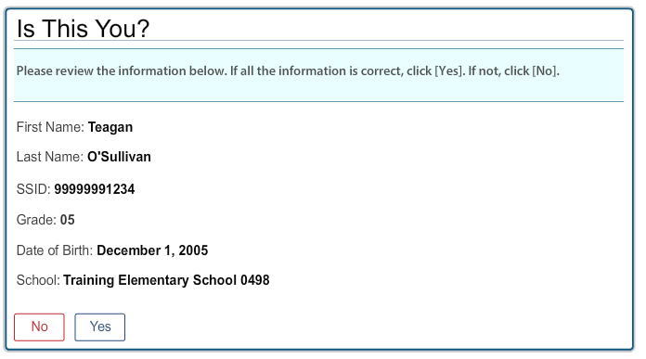
- Eligible tests are listed and students will click test
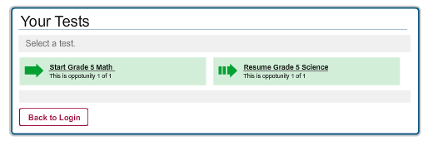
- Students will see a screen to wait for Test Administrator Approval
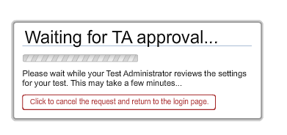
*All tests must be approved before by test administrator before they may begin

How to Approve and Review Students
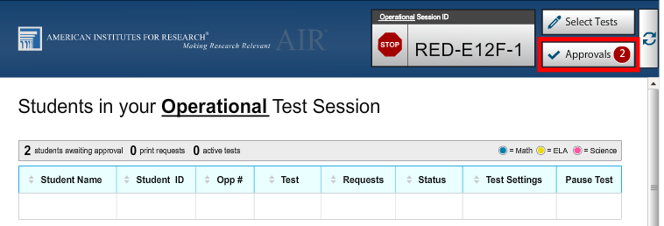
Helpful Hint:
Select Refresh Button if approvals not immediate
- Select Approvals button to approve students for testing (found at top right of screen)
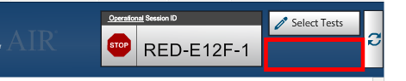
Blank space means NO students need approval
- Approvals and Student Test Setting Screen help you identify students WITH and WITHOUT accommodations (Standard vs Custom)
-Note- Accommodations have already been entered into TIDE but please verify that your students have CUSTOM details listed
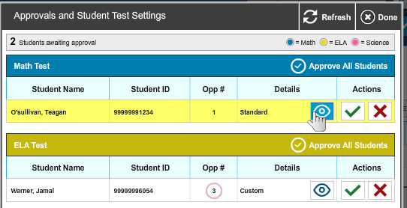
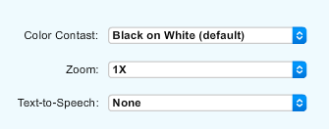
- Select the Approves All Students button
- Once approved you will see a list of students in
Status Column shows the questions students are on
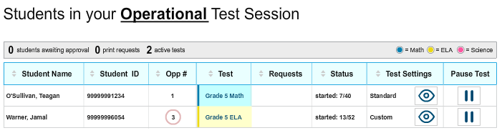
Student View After Test Administrator Approval
- After students have been approved, it will ask if information is correct. If yes, then students will select Yes, Start My Test
*If incorrect, then select NO and notify Test Administrator
- Some test prompt SOUND check. Select speaker icon
If audio is clear, then student will select YES
If audio is NOT clear, then student will select NO
-after student selects NO, then ask them to log out of secure browser
-TA (test administrator) will change settings on headphones
-log back into AzMERIT secure browser
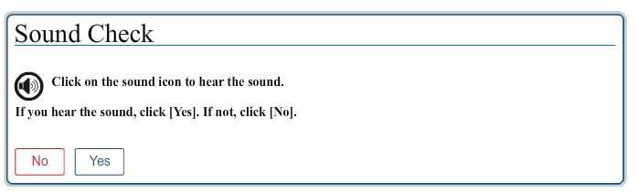
- Test Instructions & Help box provide online tools & keyboard shortcuts)
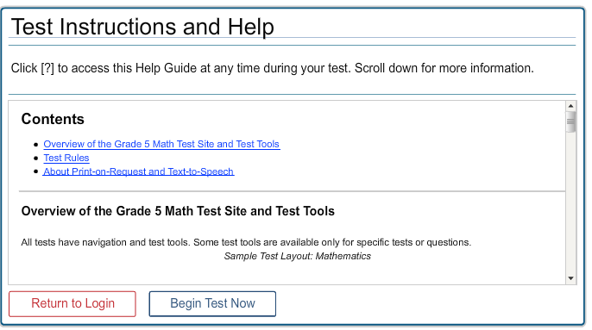
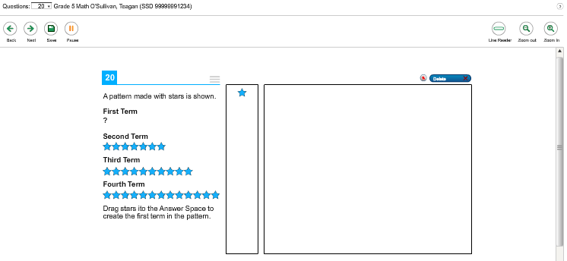
- Students will select Begin Test
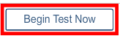
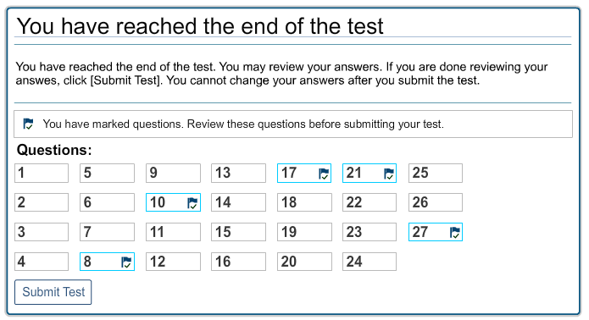
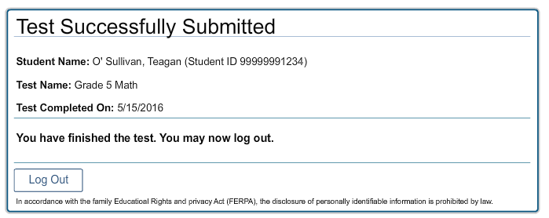
- Submit Test & Log Out
*Students prompted
to review answers
How to PAUSE Test
- Pause a student’s test at any time by clicking Pause Test button
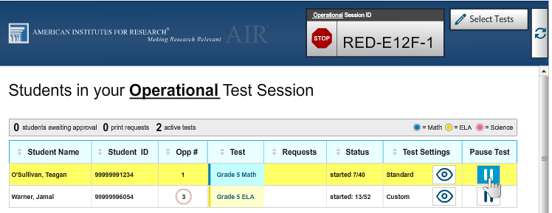
- If a student test is paused, then the student will have to log back in within a certain amount of time
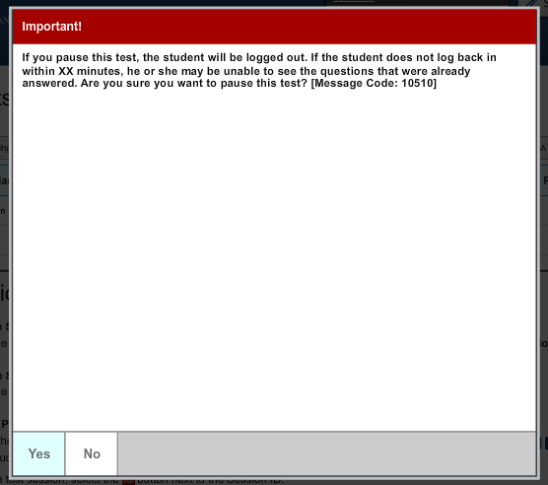
- Test Administrator will have to go through Approving and Reviewing Students process again
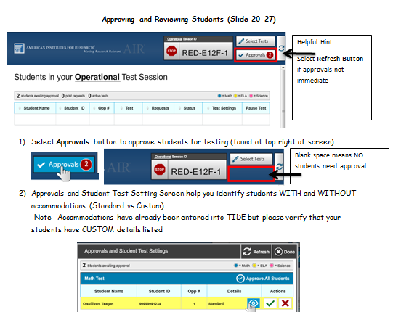
- Student will have to log back in and BEGIN on the next unanswered question
How to END Session
- To End Session click the RED STOP SIGN
- Confirm that you would like to STOP session
