Teacher Sign In for Sample Test 2019
- Go to www.azmeritportal.org
- Click Students & Families
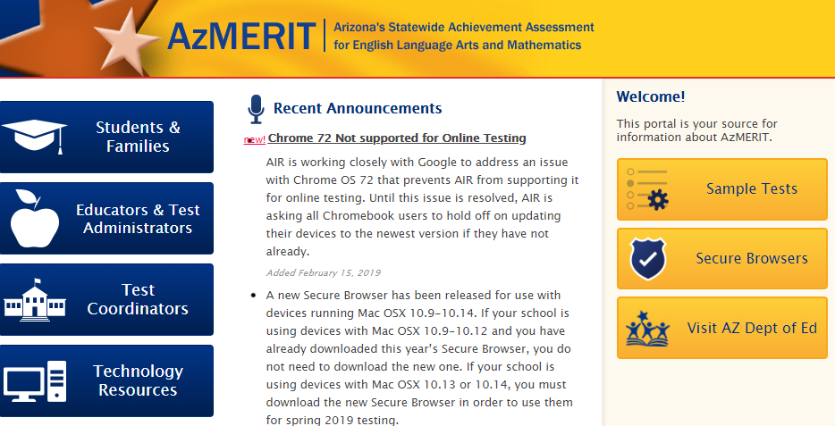
- Click Sample Tests
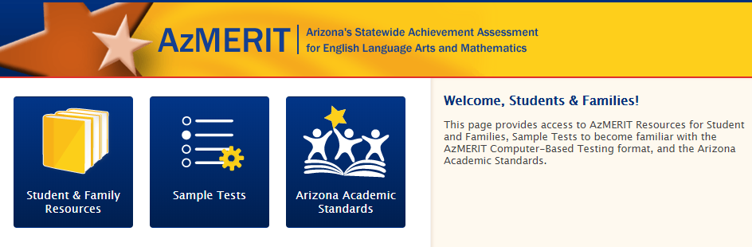
- Click Administer Sample Tests
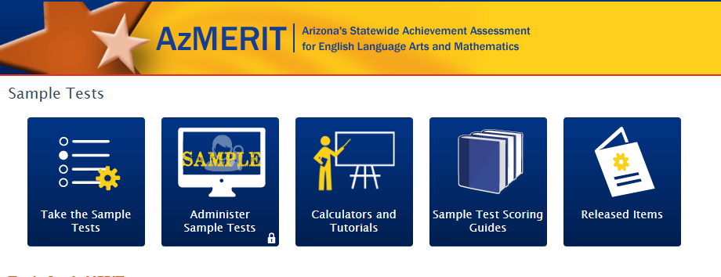
- Login to AzMERIT Secure Browser
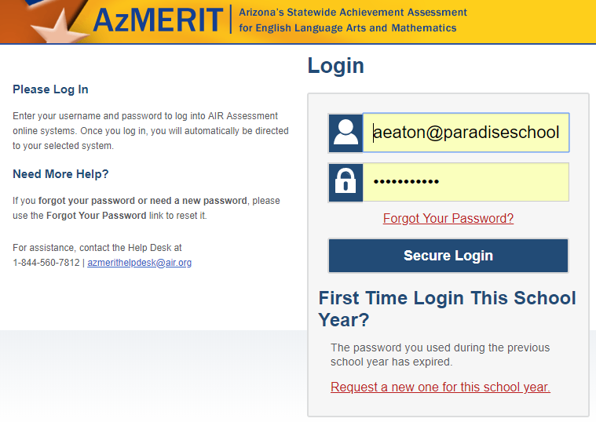

- Click Pop Up Blocker and Allow and Done and Refresh
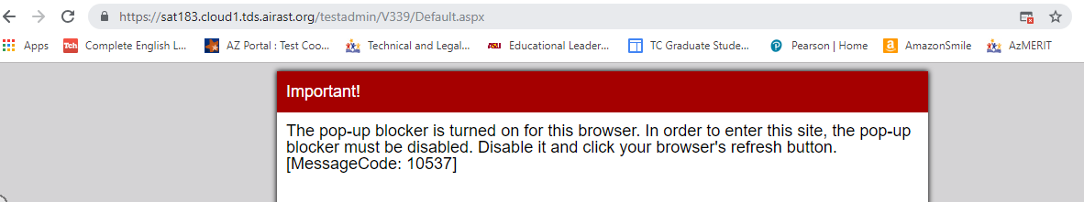
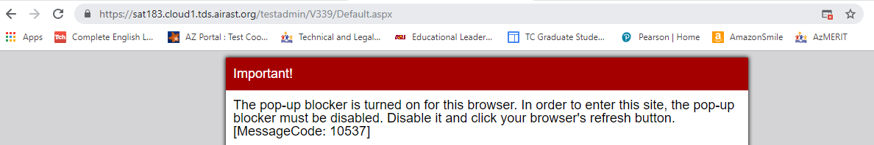
- Choose Sample Test and Grade Level and Start Sample Session
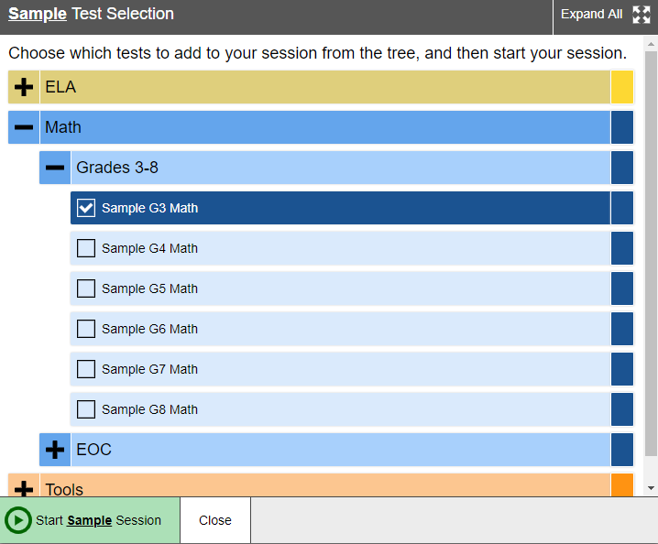
- Write Session ID on board and APPROVE ALL when students sign into Test
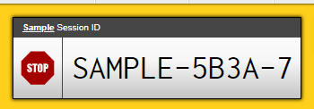

Student Sign In for Sample Test 2019
- Go to www.azmeritportal.org
- Click Students & Families
- Click Sample Tests
- Click Take Sample Test
- Toggle ON within Guest Session and Enter Session ID and Sign In and Wait for Approval
