University of Victoria 2008 Grade 3
http://web2.uvcs.uvic.ca/courses/elc/studyzone/200/reading/

Pro-Provides 8 multiple choice questions with immediate feedback for 2 passages. The comprehension questions are split screen so students can refer back to text. Also, students have option to complete Fill in the Blank questions.
Con-Fill in the blank questions have same concept of pull down menu but not the same format. Names and spelling are different due to origin of source (example practise)

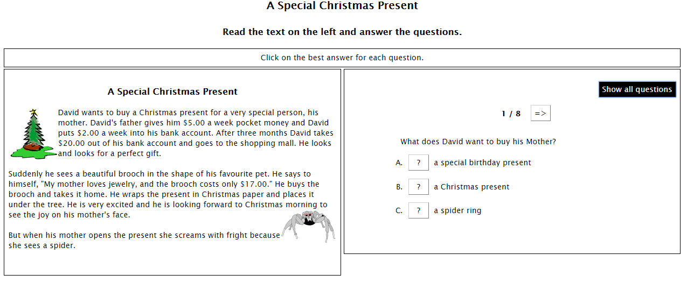
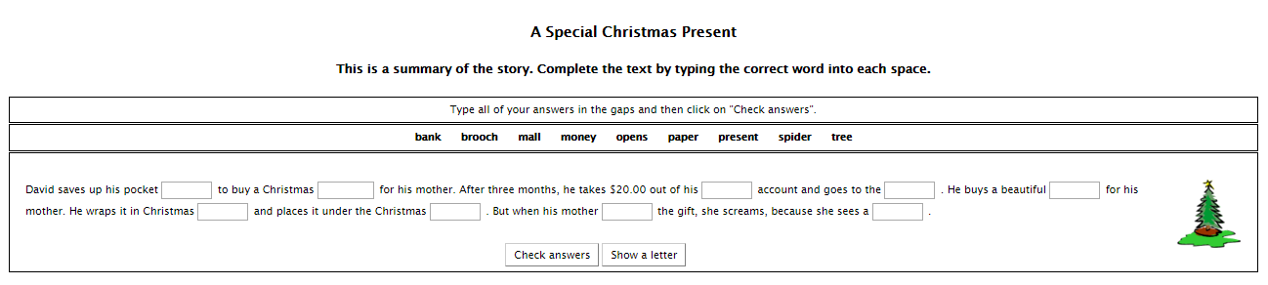

AzMerit Format of Pull-Down Questions
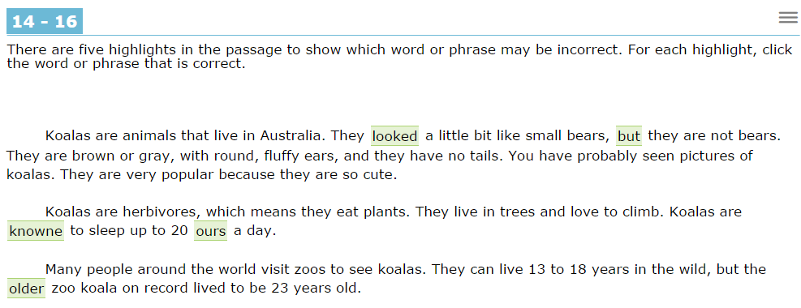

University of Victoria 2008 Grade 4
http://web2.uvcs.uvic.ca/courses/elc/studyzone/330/reading/

Pro-Provides multiple choice questions with immediate feedback for 12 passages. The comprehension questions are split screen so students can refer back to text. Also, students have option to complete Fill in the Blank questions.
Con-Fill in the blank questions have same concept of pull down menu but not the same format. Names and spelling are different due to origin of source. The next level higher level passages are NOT APPROPRIATE for students.
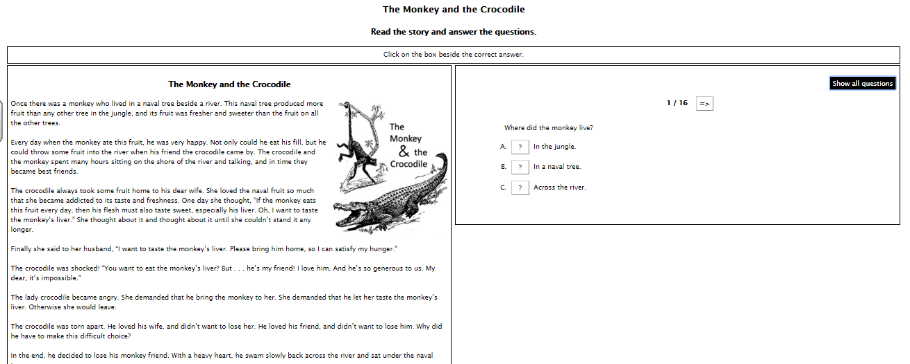
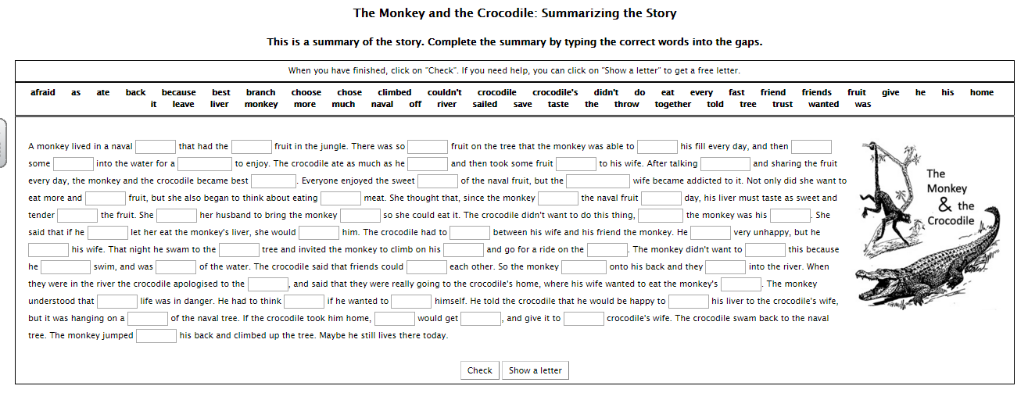
AzMerit Format of Pull-Down Questions
University of Victoria 2008 Grade 5
http://web2.uvcs.uvic.ca/courses/elc/studyzone/330/reading/

Pro-Provides multiple choice questions with immediate feedback for 5 passages. The comprehension questions are split screen so students can refer back to text.

Con- Names, spelling, and weight are different due to origin of source. The next level below is NOT APPROPRIATE passages for students. The passage, The Effects of Stress, discuss acholohism and addiction.

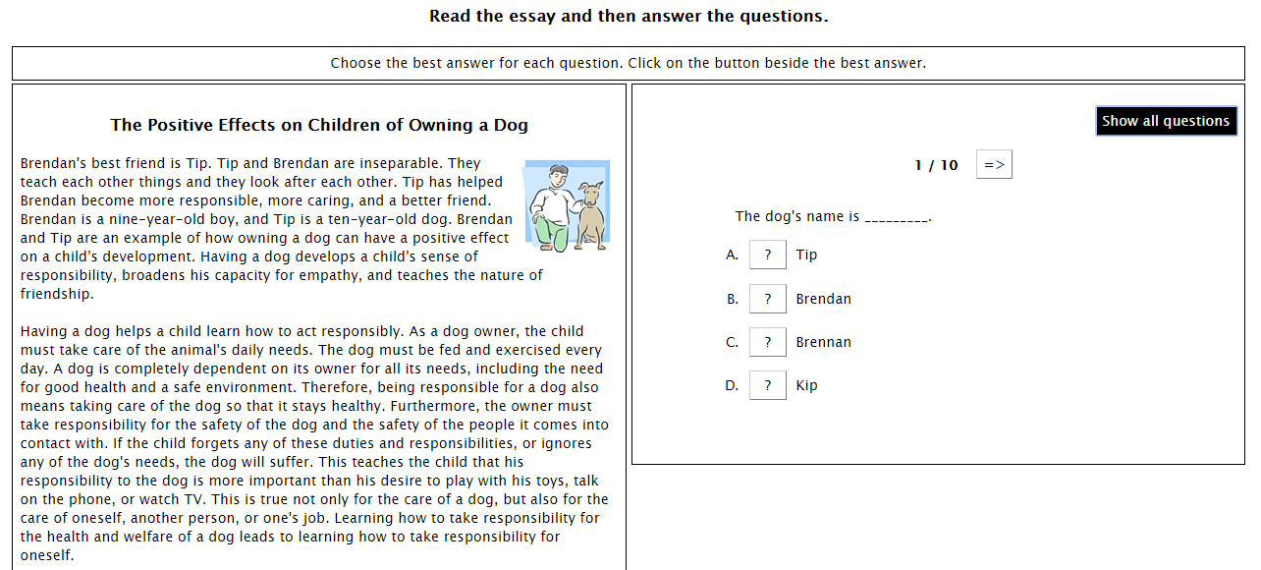
AzMerit Format with Split Screen
